**Title**: Neurocomputational mechanisms underlying perceptual and response switching

**Authors**: Ziyi Huanga, Yu Zhanga, Yun Yanga, Wanyun Zhaoa, Yifeixue Yang, and Dazhi Yina, b, *

**Author affiliations**: a Shanghai Key Laboratory of Brain Functional Genomics (Ministry of Education), Affiliated Mental Health Center (ECNU), School of Psychology and Cognitive Science, East China Normal University, Shanghai 200062, China;

b Shanghai Changning Mental Health Center, Shanghai 200335, China

**\*Correspondence author**: Dazhi Yin (dzyin@psy.ecnu.edu.cn).

**Introduction**: Cognitive flexibility manifests in switching between various types of mental sets. Perceptual switching (PS) refers to switching between perceptual sets (e.g. visual representations of stimuli), while response switching (RS) refers to switching between response sets (Kim et al., 2012; Rushworth et al., 2002). It is not clear whether the two types of cognitive flexibility differ in task preparation and execution (Kiesel et al., 2010), and whether the two stages were supported by the same functional network.

**Materials and Methods**: A total of 66 (33 males) healthy college students performed PS and RS tasks in the magnetic resonance imaging (MRI) scanner. In the PS task, participants were instructed to perform a color discrimination task or a direction discrimination task when they were presented with a red or blue arrow. In the RS task, participants were instructed to respond to a horizontal or vertical line with two reversal response rules. A fixation cross was presented for 700 ms followed by a graphical cue that indicated the task rule and lasted for 300 ms. When the cue disappeared, the stimulus was presented for 1 s, and participants had 2 s to respond with their right index or middle finger. The inter-trial interval was 2-8 s. In repeat trials, the current task rule was the same as the prior trial, whereas in switch trials, the current task rule was different from the prior trial. Switch cost was defined as the performance differences between switch and repeat trials. For each switching task, there were 128 trials in a pseudo-random sequence, and the proportion of each subtask and each condition (switch or repeat) was about 50%.

For behavioral data, we first examined switch costs for each task and compared them using paired t-tests. Then we decomposed the reaction time (RT) for each task using the drift-diffusion model. The non-decision time (t0) and drift rate (v), corresponding to task preparation and task execution stages, were allowed to vary over switch and repeat conditions (Schmitz & Voss, 2012). The switch cost of t0 and v (switch vs. repeat) were compared between PS and RS.

For functional MRI data, the first-level general linear model (GLM) was applied to preprocessed images in the SPM12 toolbox. Brain activation was defined as the activity differences between switch and repeat conditions. The Power264 atlas (Power et al., 2011) was used to obtain network-level activations. Correlation analyses were performed between switch costs (RT, t0, and v) and brain activations.

**Results:** (1) We observed significant RT switch costs in PS and RS tasks (*t* (1,60) > 8.22, *p* < 0.001), but the RT switch cost did not differ across tasks (*t* (1,60) = 0.23, *p* = 0.82). (2) As indicated by WAIC values, the optimal models were the same across tasks where non-decision time and drift rate both varied over switch and repeat trials, the RS task showed a larger non-decision time difference (switch vs. repeat) compared with the PS task (*t* (1,60) = 4.67, *p* < 0.001), whereas the PS task showed a larger drift rate difference (switch vs. repeat) relative to the RS task (*t* (1,60) = 3.70, *p* < 0.001). (3) In both tasks, no significant correlations were found between brain activation and RT switch cost (*r* < 0.21, *p* > 0.13). (4) In the RS task, activation of the frontoparietal network (FPN) was correlated with non-decision time differences (*r* = 0.29, *p* = 0.04), while in the PS task, activation of the FPN was relevant to drift rate differences (*r* = 0.29, *p* = 0.04).

**Conclusion:** Task preparation may be more crucial for the switch cost of response switching compared with perceptual switching, while task execution may play a more important role in the switch cost of perceptual switching relative to response switching. Activation of the FPN supports the performance of perceptual and response switching at different stages. Our findings reveal dissociable cognitive mechanisms and the underlying neural supports of perceptual and response switching.

**References**

Kiesel, A., Steinhauser, M., Wendt, M., Falkenstein, M., Jost, K., Philipp, A. M., & Koch, I. (2010). Control and interference in task switching—A review. *Psychological Bulletin*, *136*(5), 849.

Kim, C., Cilles, S. E., Johnson, N. F., & Gold, B. T. (2012). Domain general and domain preferential brain regions associated with different types of task switching: a meta-analysis. *Human Brain Mapping*, *33*(1), 130–142. https://doi.org/10.1002/hbm.21199

Power, J. D., Cohen, A. L., Nelson, S. M., Wig, G. S., Barnes, K. A., Church, J. A., Vogel, A. C., Laumann, T. O., Miezin, F. M., & Schlaggar, B. L. (2011). Functional network organization of the human brain. *Neuron*, *72*(4), 665–678.

Rushworth, M. F. S., Hadland, K. A., Paus, T., & Sipila, P. K. (2002). Role of the human medial frontal cortex in task switching: a combined fMRI and TMS study. *Journal of Neurophysiology*.

Schmitz, F., & Voss, A. (2012). Decomposing task-switching costs with the diffusion model. *Journal of Experimental Psychology: Human Perception and Performance*, *38*(1), 222.

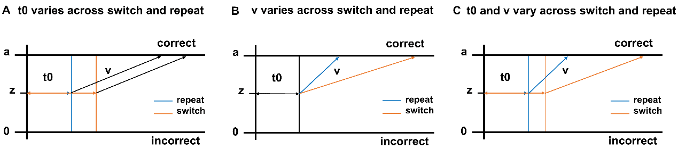

**Fig. 1.** Drift-diffusion models of perceptual and response switching. A. Only t0 is allowed to vary across switch and repeat trials; B. Only v is allowed to vary across switch and repeat trials; C. Both t0 and v are allowed to vary across switch and repeat trials. a: response criteria; z: starting point; t0: non-decision time; v: drift rate.

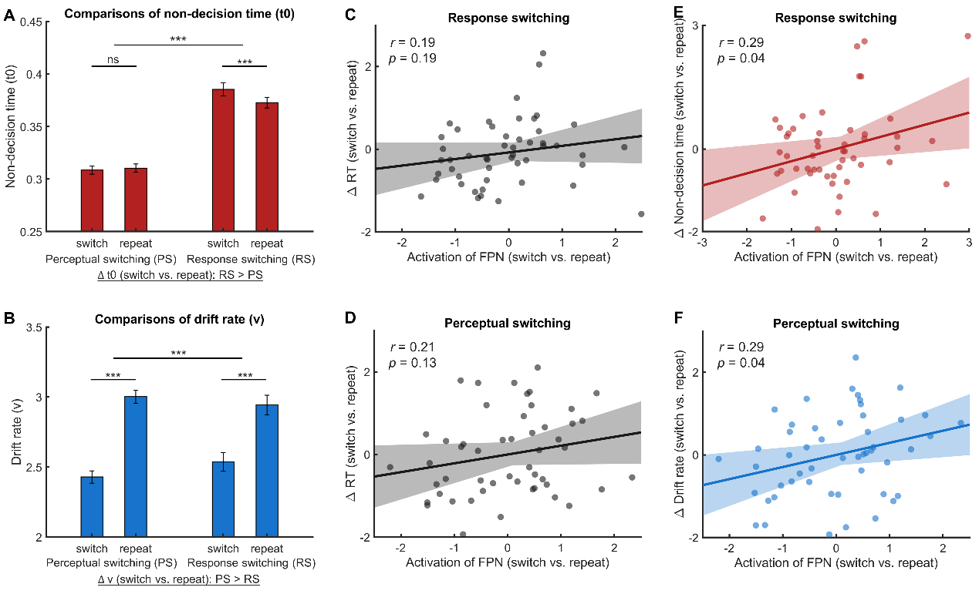

**Fig. 2.** Comparisons of model parameters and correlations between behavioral scores and activation of the frontoparietal network (FPN). A. Comparisons of non-decision time (t0): the RS task showed a larger t0 difference (switch vs. repeat) compared with the PS task. B. Comparisons of drift rate (v): the PS task showed a larger v difference (switch vs. repeat) relative to the RS task. C-D. In both tasks, no significant correlations were found between activation of the FPN and RT switch cost. E. In the RS task, activation of the FPN was correlated with t0 differences. F. In the PS task, activation of the FPN was correlated with v differences. PS: perceptual switching; RS: response switching; RT: reaction time; Error bar: standard error of the mean; 95% confidence interval is highlighted in light color; ns: not significant; *** *p* < 0.001.